

**WEIGHING SYSTEM** (Standard Software) **OPERATIONS MANUAL**

**TABLE OF CONTENTS**

1. **INSTALLATION GUIDE pg. 1**
2. **LOG-IN FORM pg. 2** 
   1. **Login Tab**
   2. **Server Connection Tab**
3. **MAIN MODULE pg. 3**
4. **USER CONTROL pg. 4** 
   1. **Creating New User**
   2. **Modifying User**
   3. **Removing User**
5. **SYSTEM SETTINGS pg. 4** 
   1. **General Settings** 
      1. **Transaction Type**
      2. **System Unit Weight**
      3. **Enable Pricing**
      4. **Enable Ticket Printout**
      5. **Indicator Type**
   2. **Serial/Comm Ports**
   3. **Database Settings**
   4. **Reference Settings**
   5. **Company Profile**
   6. **Backup Data**
6. **DATABASE MAINTENANCE pg. 7** 
   1. **Adding New Data**
   2. **Modifying/Editing Data**
   3. **Deleting/Removing Data**
7. **WEIGHING TRANSACTIONS pg. 8** 
   1. **Creating Transaction**
   2. **Reprinting of Weighing Ticket**
   3. **Deleting Transaction**
8. **TRANSACTION MANAGEMENT pg. 10** 
   1. **EDITING TRANSACTION**
   2. **DELETING TRANSACTION**
   3. **REPRINTING TRANSACTION**
9. **REPORTING pg. 12** 
   1. **Generating Summary Reports**
   2. **Setting the Date Range**
   3. **Filter Panel**
   4. **Printing and Viewing Reports**

# 1. INSTALLATION GUIDE

**STEP 1:** Install Microsoft Office Application (2003 or higher version)

**STEP 2:** Install dotNetFx40_Full_x86_x64.exe

**STEP 3:** Install CRRuntime_32bit_13_0_8 .exe for 32 bit OS **STEP 4:** Install Weighing System v1.1 Setup Just Click Next.

**STEP9 (Optional):** Install DTECH USB2SERIAL Driver if your machine doesn’t have a built-in Communication Port.

**STEP10:** To Setup Weighng System Port Connection, follow the instruction below Device Manager Window

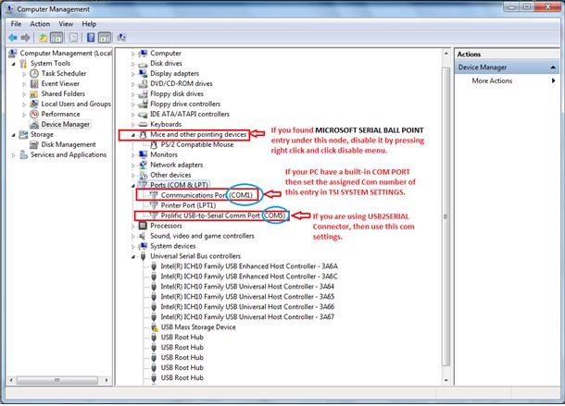

# 2. LOGIN FORM

## 2.1 LOG-IN TAB

Every user must enter the user name and password to access Weighing System. For fresh installed, user name is *admin* and password is *1.*

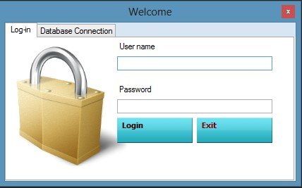

## 2.2 DATABASE CONNECTION TAB

In this Section, you can choose the database file (MDB file) that you want to use. Just Click

to browse to the location of the DB File, type in database password then

edit and click

press.

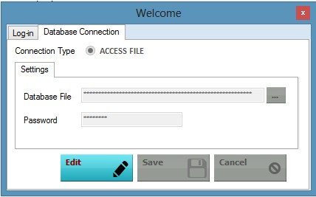

# 3. MAIN MODULE

For Successful login and server connection, main module will appear.

Just Click

to log out your account

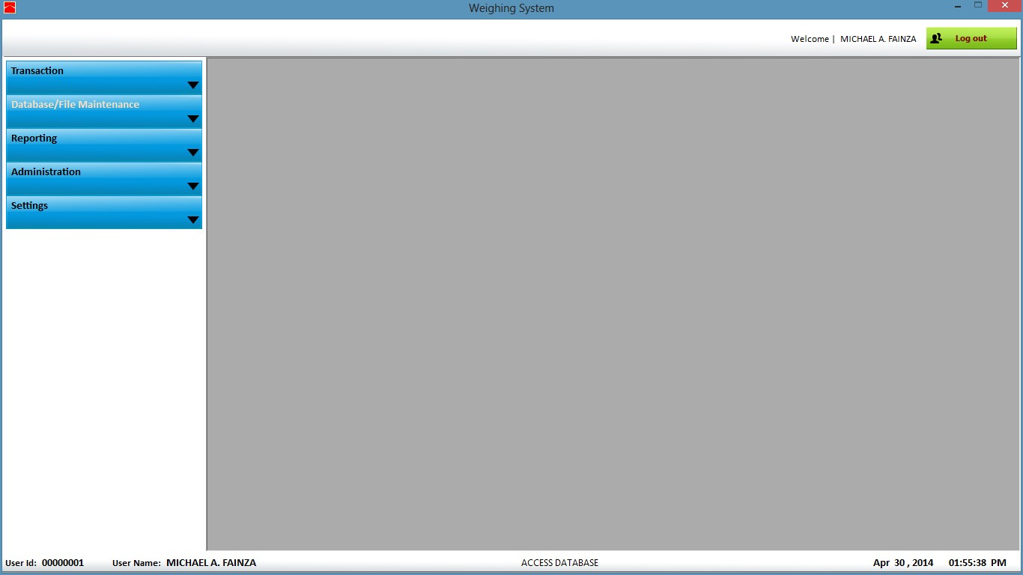

# 4. USER CONTROL

*Fig. 4a*

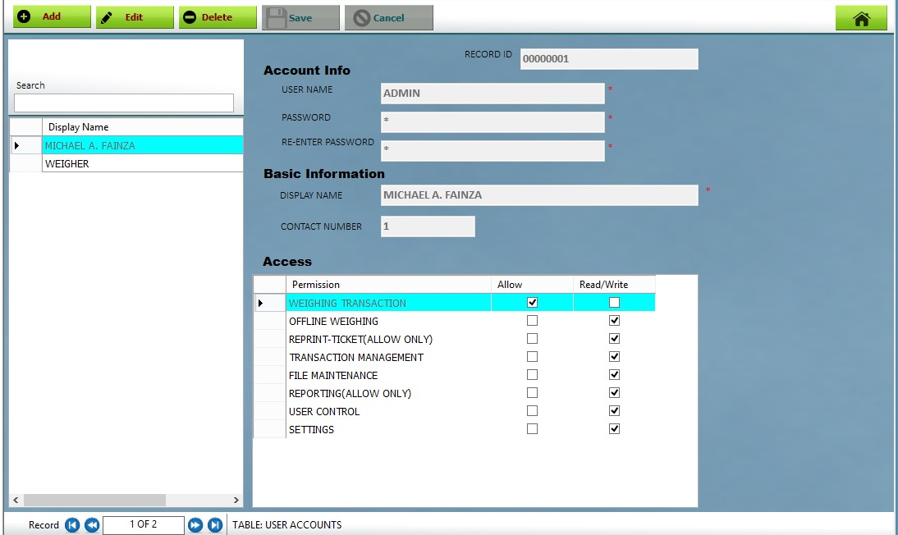

## 4.1 CREATING NEW USER

Go to ***MAIN MODULE-> ADMINISTRATION->User Accounts*** . Just Click  and enter your display name (Name that you want to appear on your weighing ticket), User name and password for your login account, Check the desired permission to the user then

click .

## 4.2 MODIFYING USER

To modify user, click  and set your desired info and features then click

. System will prompt you to logout the system to refresh changes made to your

accont

## 4.3 REMOVING USER

To remove or delete user, highlight the row/s or user that you want to delete then click

 and click yes for confirmation. *Note: You cannot delete user that is currently*

*logged-in.*

# 5. SYSTEM SETTINGS

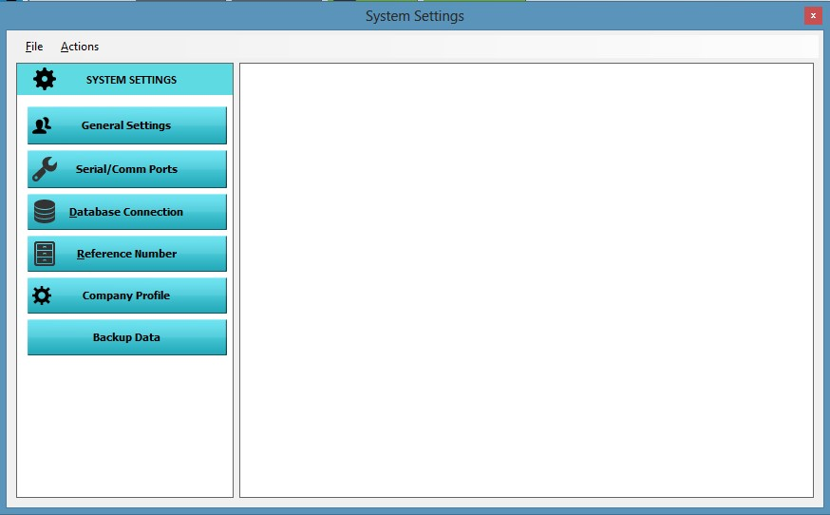

## 5.1 GENERAL SETTINGS

### 5.1.1 TRANSACTION TYPE

* **Single Weighing -** Enable this option if you want to use the software as a Single Weigh transaction.
* **In/Out Weighing –** Enable this option if you want to use the software as a standard weigh-in and out transaction.

### 5.1.2 SYSTEM UNIT WEIGHT

* **Kg -** Converts Weight Device Signal to Kilogram
* **Tons**  **-** Converts Weight Device Signal to Tons

**5.1.3 ENABLE PRICING –** ToEnable Pricing, Just click Edit Button and check

 then click Save.

* **Unit Per Price**

**Per Kilogram -** Computes Total Amount in Per Price per Kilo. **Per Tons -** Computes Total Amount in Per Price per Kilo.

**5.1.4 ENABLE /DISABLE TICKET PRINTOUT -** Enables/Disables Ticket Printout during Transaction.

* **Print In and Out Separatly -** 2 printings will occur for every transaction.

Inbound details will be printed separately to outbound details.

* **Print All details at Weigh-Out** - Prints all details during Outbound only.

**5.1.5 Indicator Type –** Selection for Indicator that you are currently using. (GSE or Rinstrum Brand.)

**5.2 SERIAL/COMM PORTS**

## 5.3 DATABASE SETTINGS - Same as section *2.2*

**5.4**  **REFERENCE SETTINGS -** Lets you set your desired transaction reference no. To edit reference no. just click edit button, Type the desired reference from the textbox provided and click save.

**5.5 COMPANY PROFILE –** Lets you store a brief Information about your company such as Name and address with corresponding Photo.

**5.6 BACKUP DATA –** Creates a copy of your database(access file) for backup purposes.

**-** To create a backup, just click  , browse to the location where you want your database to be backuped then click save.

# 6. DATABASE/FILE MAINTENANCE

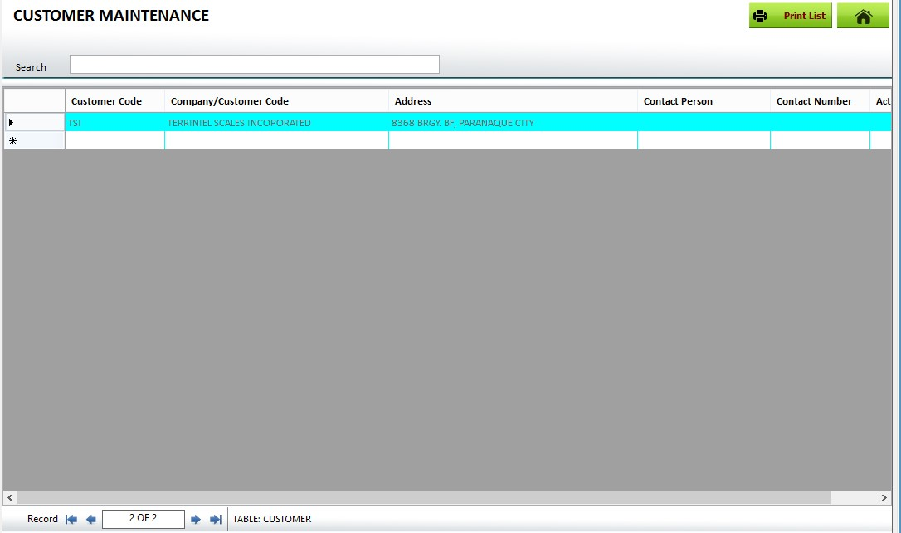

## 6.1 ADDING NEW DATA

**STEP 1**: Under the Main Menu Window, Click 

**STEP 2**: Click from the button where you want to add/modify/delete data.

**STEP 3:** Just Scroll down to the empty row and type in the data that you want to add then press enter.

## 6.2 MODIFYING/EDITING DATA

**REPEAT STEP 1 & 2**

**STEP 3**: Just Scroll to the row of the data that you want to modify, just type in the changes then press enter.

## 6.3 DELETING/REMOVING DATA

**REPEAT STEP 1 & 2**

**STEP 3**: Just Scroll to the row of the data that you want to delete then press Delete button on your keyboard then press yes for message box confirmation that appeared.

# 7. WEIGHING TRANSACTIONS

*Fig 7.1a*

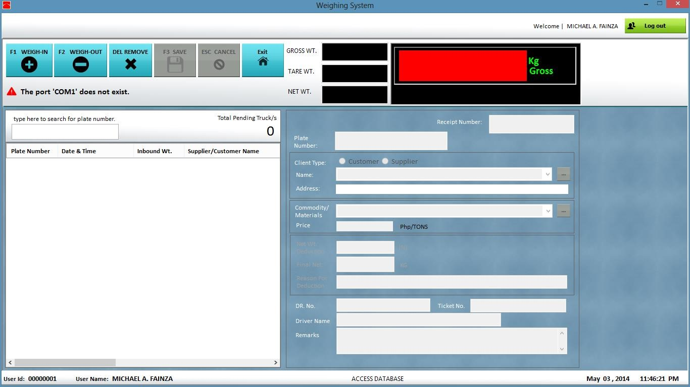

*Fig 7.1b*

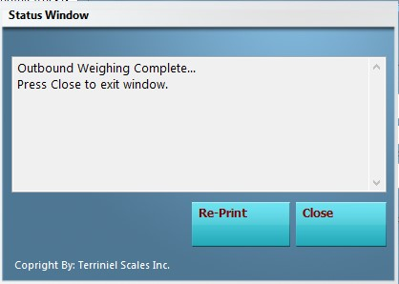

## 7.1 CREATING TRANSACTION

**STEP 1:** Go to ***TRANSACTION -> TRANSACTION- >WEIGH-IN*** (*see Fig 7.1a).*

**STEP 2:** Enter the Required field and wait for the Device weight to get stable then click SAVE or Click CANCEL to void transaction. A printout will occur if the In and Out printing is enabled in the system settings. Status window *(see fig. 7.1b)* will appear if saving is successful.

**STEP 4:** If an entry is ready for outbound then, select the entry from queue list to the left and click **WEIGH-OUT**

**STEP 5:** Wait again for the signal to get stable and click SAVE or CANCEL. You can edit your transaction data during outbound operation. . Status window will appear again if saving is successful. You can reprint again the Ticket by pressing Re-Print in the status window

**NOTE:**

* *(A short cut button*  *is provided to easily add or register Customer/Supplier or Commodity to your database.)*
* *If Weight Signal Panel turns Red, then the weight device connection is not successful or committed an error while connecting. An error message will appear below the buttons.*

## 7.2 REPRINTING OF WEIGHING TICKET

**Option 1:**

Under the Status Window, Click re-print button and click yes to confirm re-printing of ticket. *(For Inbound Only.)*

**Option 2:**

**STEP 1**: Go to ***MAIN MENU->TRANSACTION-> MANAGEMENT.***

**STEP 2:** Press Inbound if the needed record is a pending transaction and

Outbound if it is a completed transaction. (You can Set date range to filter easily filter the record that you want to list.

**STEP 3:** Select the desired transaction record then click Re-Print button

## 7.3 DELETING TRANSACTION

**Option 1:**

Under the transaction window, select from the queue list, Press delete button and click yes to continue removing of transaction. *(For Inbound Only.)*

**Option 2:**

**STEP 1**: Go to ***MAIN MENU->TRANSACTION-> MANAGEMENT.***

**STEP 2**: Press Inbound if the needed record is a pending transaction and

Outbound if it is a completed transaction. (You can Set date range to filter easily filter the record that you want to list.

**STEP 3**: Select the desired transaction record and press delete button.

# 8. TRANSACTION MANAGEMENT

*Fig 8a TRANSACTION MANAGENT MENU*

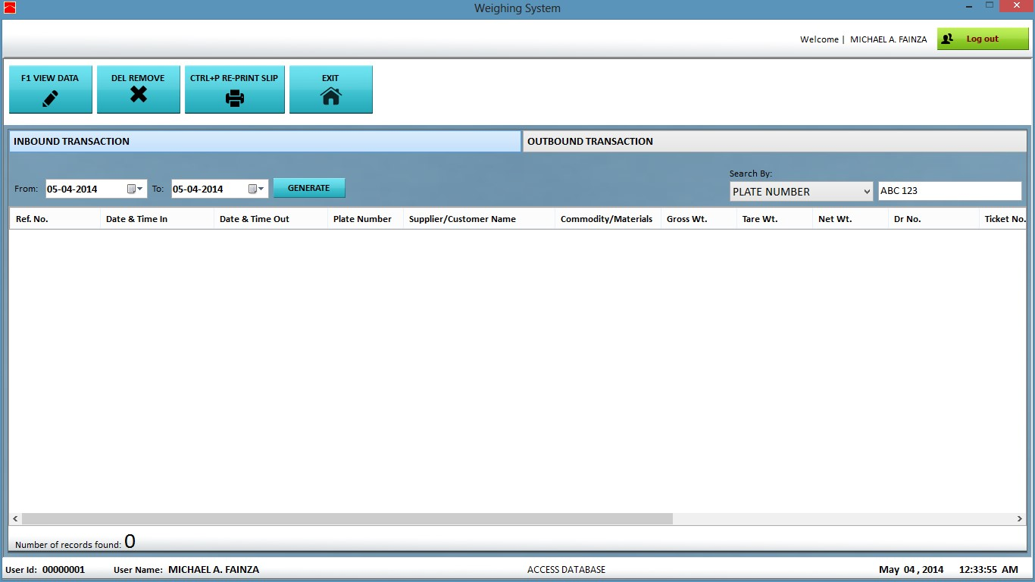

*Fig 8b TRANSACTION DETAILS*

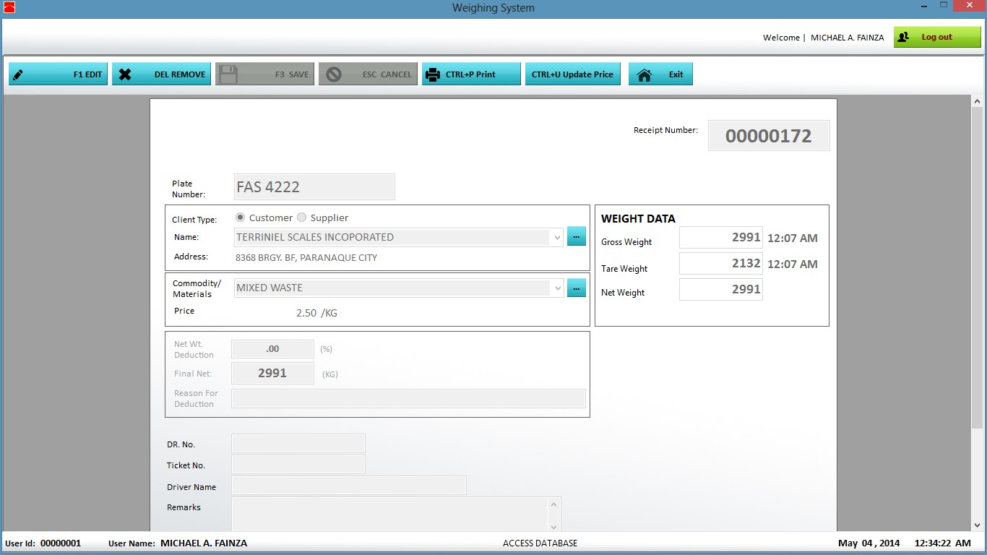

## 8.1 EDITING TRANSACTION

**STEP 1:** To edit Inbound/Outbound transaction, go to ***MAIN MODULE-> TRANSACTION->***

***MANAGEMENT (****See fig. 7a)*

**STEP 2:** Press Inbound if the needed record is a pending transaction and

Outbound if it is a completed transaction. (You can Set date range to filter easily filter the record that you want to list.

**STEP 3**: Select the desired transaction record then press VIEW DATA Button. A new window will Appear. See *Fig 8b*

**STEP 4:** Press Edit Button to enable editing

**STEP 5:** Change the desired changes then click save.

## 8.2 DELETING TRANSACTION

**STEP 1:** To Delete Inbound/Outbound transaction, go to ***MAIN MODULE-> TRANSACTION->***

***MANAGEMENT (****See fig. 7a)*

**STEP 2**: Press Inbound if the needed record is a pending transaction and

Outbound if it is a completed transaction. (You can Set date range to filter easily filter the record that you want to list.

**STEP 3:** Select the desired transaction record and press delete button.

## 8.3 REPRINTING TRANSACTION

(*Make sure Print-out is enabled in the system settings)*

**STEP 1**:To reprint Inbound/Outbound transaction, go to ***MAIN MODULE-> TRANSACTION->***

***MANAGEMENT (****See fig. 7a)*

**STEP 2:** Press Inbound if the needed record is a pending transaction and

Outbound if it is a completed transaction. (You can Set date range to filter easily filter the record that you want to list.

**STEP 3:** Select the desired transaction record then press Re-print button.

# 9. REPORTING

*Fig. 9.1a*

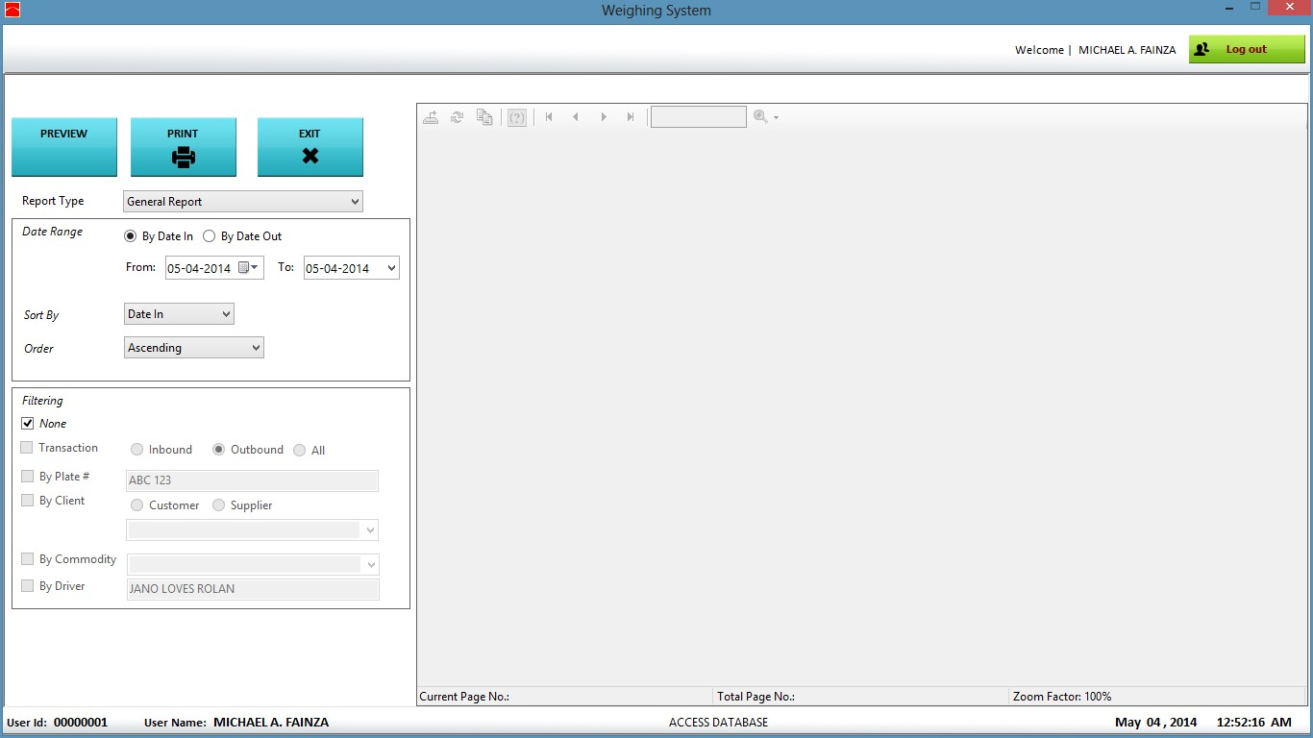

## 9.1 GENERATING SUMMARY REPORTS

To generate or make a summary reports, go to ***MAIN MODULE-> REPORTING-> SUMMARY REPORTS.***

## 9.2 SETTING THE DATE RANGE

**9.2.1 DATE RANGE** - Transaction date can be generated by Date In(Inbound date) or Date Out(outbound date) depending on your needs and can be sorted by the following fields

**9.2.2 SORT BY** *– (Date In, Date Out, Final Net, Reference No.)* Lets you select the fields where you want your report to be arranged.

**9.2.3 ORDER BY –**Report can be ordered in ascending, descending or original position.

## 9.3 FILTER PANEL

To enable filtering of reports, just check and check also the desired filter category. **9.3.1 Transaction Type** *(Not applicable to Single Weighing Transaction)*



***INBOUND*** – selecting this option will generate only pending transaction ***OUTBOUND*** – selecting this option will generate only completed transaction ***ALL*** – all transaction type will be generated*.*

**9.3.2 Plate Number** - just check and type in the plate number that you want

to filter.

**9.3.3 Client** - to filter client, just check , Selecting the registered customer in the dropdown box below same with selecting .

will list the



After the listing, just select the desired client

**9.3.4 Commodity** - to include commodity in the filter, just check  and select the desired commodity name.

**9.3.5 Driver** - To also filter driver, just checkand type in the driver name.

## 9.4 PRINTING AND VIEWING REPORTS

After settings the date range and the filter, just click to make the report

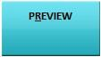

appear or refresh in the preview panel. Just click if you are ready to print your report.

**WEIGH SLIP FORMAT**

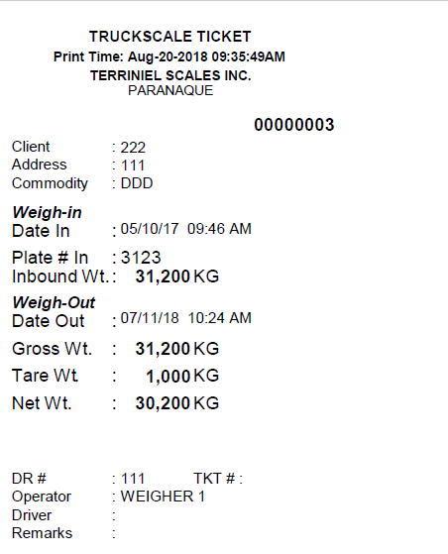

**REPORT FORMAT**

**W/ PRICING**

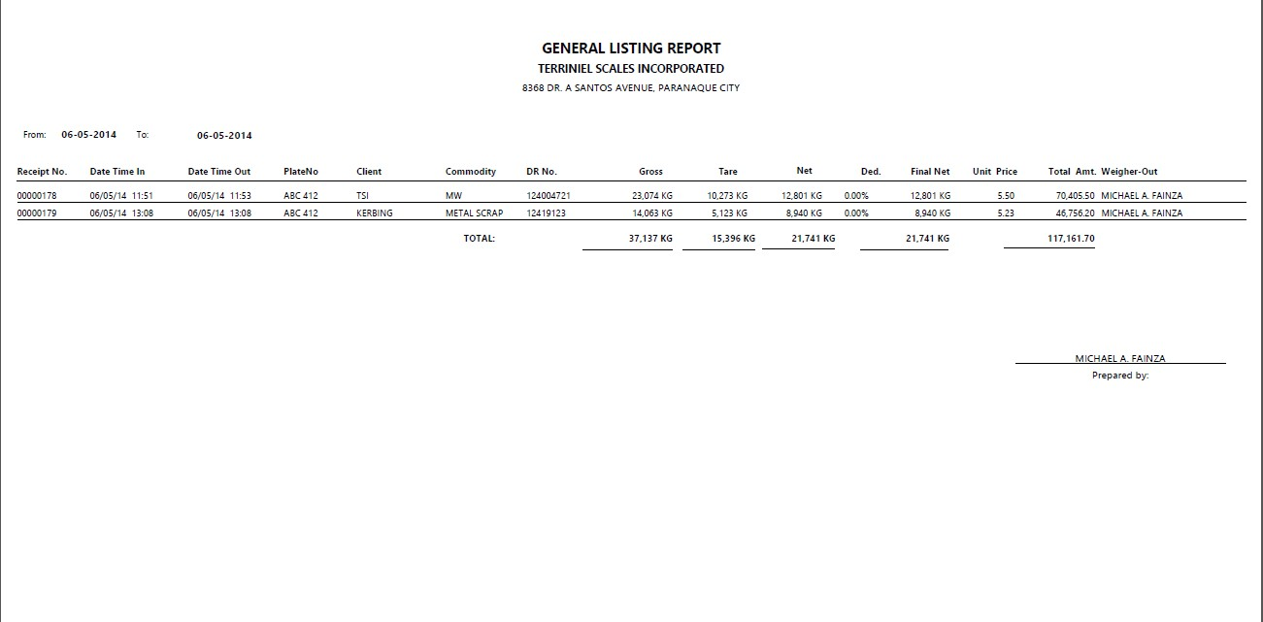

**NO PRICING**

